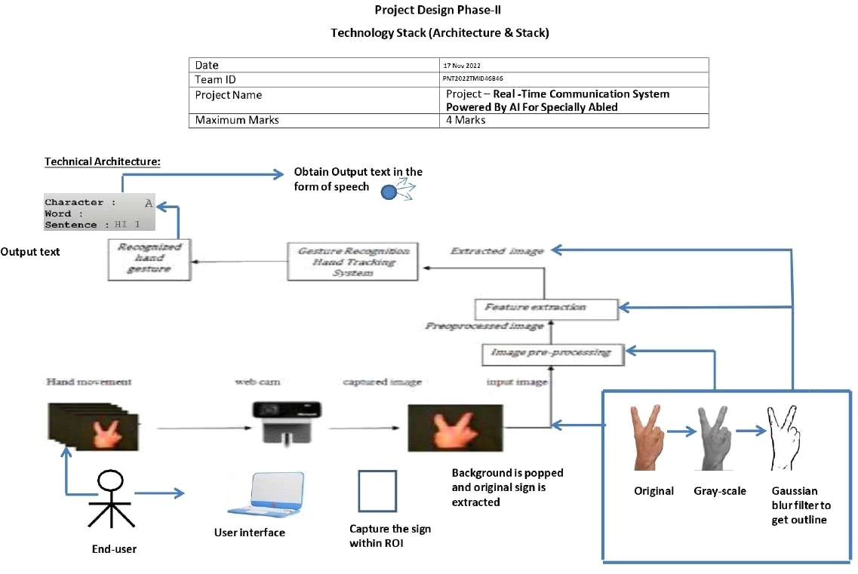

Table-1 : Components & Technologies:

|  |  |  |  |
| --- | --- | --- | --- |
| S.No | Component | Description | Technology |
| 1. | User Interface | How user interacts with application i.e. Desktop usage and clicking the concerned app. | HTML, CSS, JavaScript and Angular  JS |
| 2. | Application Logic-1 | * Camera detects the sign shown by the user. * Captures the sign within ROI. | Adaboost face detector is used to  differentiate  between faces and hand as both involves similar skincolour. |
| 3. | Application Logic-2 | • Background is popped and original sign is extracted. | By default, Original image captured is converted into Grayscale image. |
| 4. | Application Logic-3 | • Extract the edges of the grayscale image. | Apply Gaussian-blur filter and threshold to the frame taken with Open CV to get the |
|  |  |  | processed image after feature-extraction. |
| 5. | Application Logic-4 | • Convert the output text into speech | The Final text obtained is converted to speech using the speech assistant implemented , which in turn produce sound from speaker. |
| 6. | Database | * Binary Large   Object(BLOB) is the data type used to store the images in the dataset.   * /etc/mysql/my.cnf is the default configuration /  |  | | --- | | directories for MYSQL that |   is used. | MySQL database is used. |
| 7. | File Storage | • Create a BLOB column for the image files, whether they be JPEG, PNG, PSD or whatever, and then load the images into the table/column, created for them. | Local File system is used for storing the images. |
| 8. | Machine  Learning Model | Allows the user to feed a computer algorithm an immense amount of data and have the computer analyze and make data-driven recommendations and decisions based on only the input data | Supervised and Unsupervised learning model etc. |

|  |  |  |  |
| --- | --- | --- | --- |
| S.No | Characteristics | Description | Technology |
| 1. | Open-Source Frameworks | * Palm detector operates on full images and outputs an oriented bounding box. * Hand landmark takes the cropped image defined by the palm detector and returns 3D hand key points. * Gesture recognizer then classifies the previously computed   key point configuration into a discrete set of gestures | Media Pipe Framework is used. Within this  framework, the  pipeline is built as a directed graph of modular components. |
| 2. | Scalable Architecture | • It’s a Three –Tier | Convolution Neural |

Table-2: Application Characteristics:

|  |  |  |  |
| --- | --- | --- | --- |
|  |  | Architecture comprises the following technology, Convolutional neural network can be scaled in three dimensions: *depth, width, resolution*.   * Depth of the network corresponds to the number of layers in a network. * Width is associated with the number of neurons in a layer. * Resolution is the image resolution that is being passed to CNN.   Increasing the depth, by stacking more convolutional layers, allows the network to learn more complex features. | Networks is used. |